**HANDS-ON RANK FUNCTION**

—----------------------------------------------------------------------------------------------------------------------------------

**Tables: Features, Sales, Stores**

| **ROW_NUMBER()**  It is a basic rank function. It gives a result in sequential order. |
| --- |

**1. Create a separate row number for the Sales table.**

SELECT *, Row_Number() OVER (

ORDER by Dept)as RowNumber from Sales

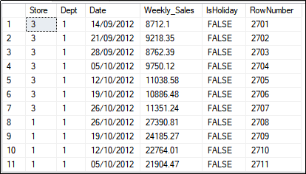

| **RANK()**  The rank function adds repeated rank to the repeated rows. |
| --- |

**2. Find out the rank of fuel price from the Features table and display it along with Store, Temperature and CPI.**

SELECT Store, Temperature, CPI, Rank() OVER (

ORDER by Fuel_Price)as Fuel_Rank from Features

**// Here the rank is skipped**

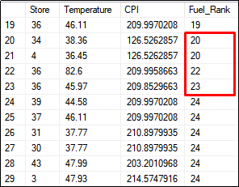

| **DENSE_RANK()**  The dense rank will never give any gaps. |
| --- |

**3. Check the dense rank based on size from the Stores table.**

SELECT *, Dense_Rank() OVER (

ORDER by Size)as Size_Dense_Rank from Stores

**// Here the rank is not skipped**

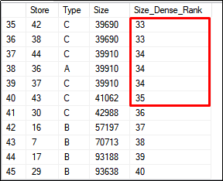

| **N_TILE()**  The NTILE is used to divide or try to partition the rows equally. |
| --- |

**4. Show the partition of 5 in your Stores table.**

SELECT *, NTILE(5) OVER (

ORDER by Size)as New_Partition from Stores

